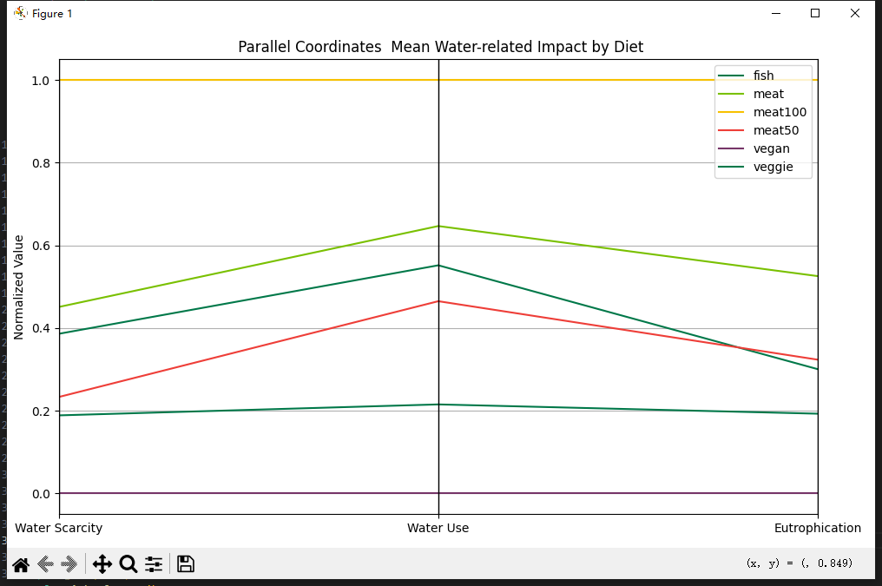

* **Visual Design Type:** Parallel Coordinates Plot
* **Tool Used:** Python
* **Diet Groups:** vegan、veggie、fish、meat50、meat100
* **Variables:** mean_watscar-(water scarcity indicators)、mean_watuse-(agricultural water consumption (cubic meters))、mean_eut-(Eutrophication potential (grams of phosphorus equivalent)).These variables reflect water-related environmental stress, and were selected based on their large inter-group variance in the dataset.
* **Visual Mappings:**

**-line** represents one diet group

**-axes** show the normalized values for the selected indicators.

**-colors** distinguish between groups.

* **Unique Observation:** The vegan diet consistently shows the lowest impact across all three indicators. In contrast, high-meat diets exhibit significantly higher burdens, particularly in water scarcity and eutrophication.
* **Data Preparation:** Data was grouped by diet group, averaged per group, then normalized before visualization.
* **Conclusion:** This advanced design uses parallel coordinates to reveal how different diets affect water-related sustainability. It clearly shows the advantage of vegan diets, making a strong case for environmentally friendly dietary choices.